

SMART COMMUNITY ISSUE REPORTING AND MANAGEMENT SYSTEAM
FULL STACK DEVELOPMENT

NAME:ABINAYA K
RRN:241541601002
DEPARTMENT:BCA AI

INTRODUCTION
CiviConnect AI is a smart community issue reporting and management system designed to help citizens report problems in their local areas. The system provides an online platform to submit complaints related to road damage, water leakage, garbage disposal, streetlights and other public issues.
The system uses artificial intelligence-based text analysis to identify the category and priority of reported issues. Administrators can view complaints, manage requests and update their status. Citizens can track their complaints using a unique complaint ID.
Workflow Diagram
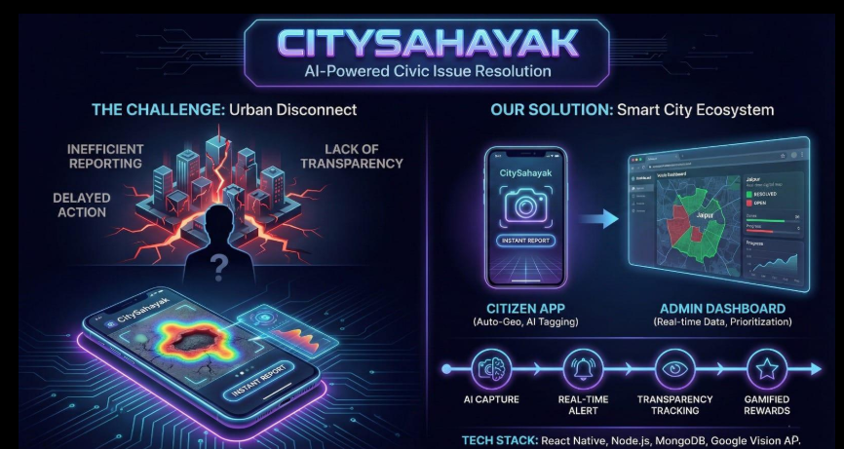

Workflow Explanation
- User Registration: New users create an account by entering their name, email and password.
- User Login: Registered users log in using their credentials.
- Report Issue: Users submit community problems with a title, description, category and location.
- AI-Based Analysis: The system analyses the complaint text and identifies its category and priority.
- Complaint Storage: Complaint details are stored in the MongoDB database.
- Admin Login: The administrator logs in to access the management dashboard.
- Complaint Management: The administrator views and manages submitted complaints.
- Status Update: The administrator changes the complaint status to Pending, In Progress or Resolved.
- Complaint Tracking: Users track the progress of their complaints using the complaint ID.

SCREENSHOT WEBPAGE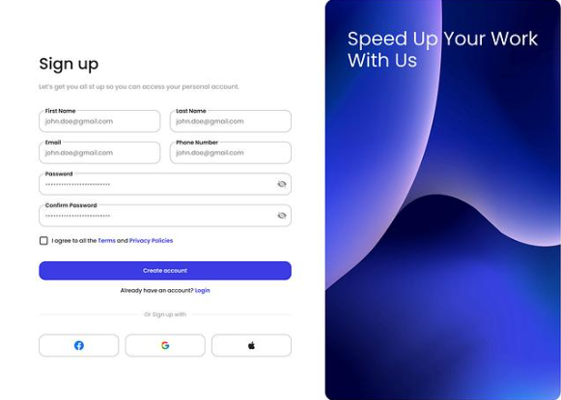 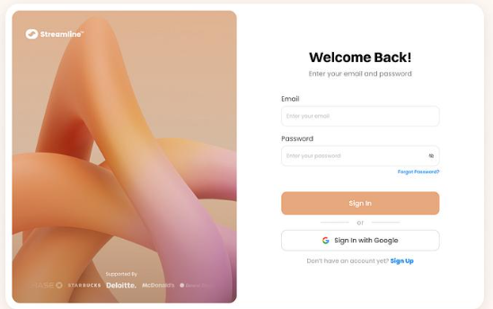
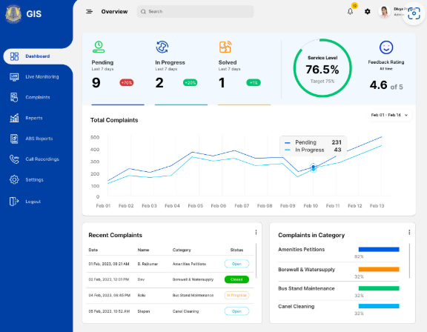

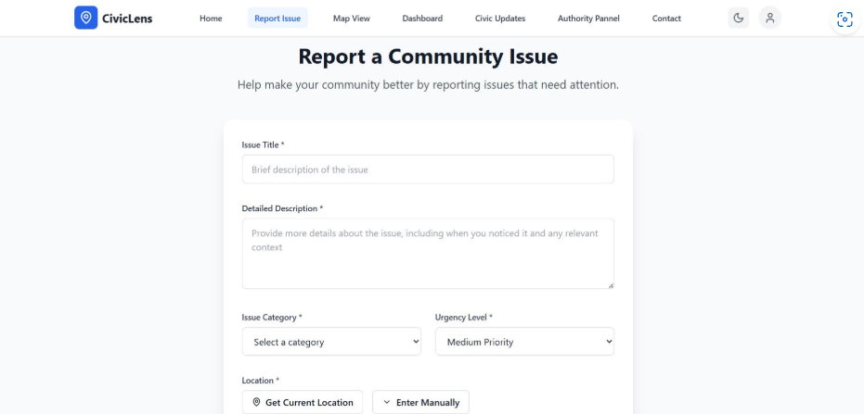

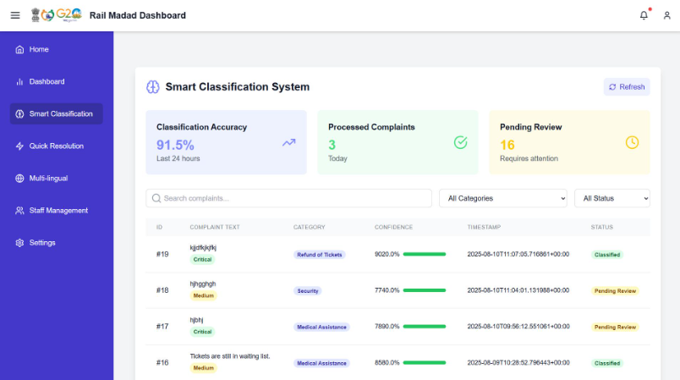

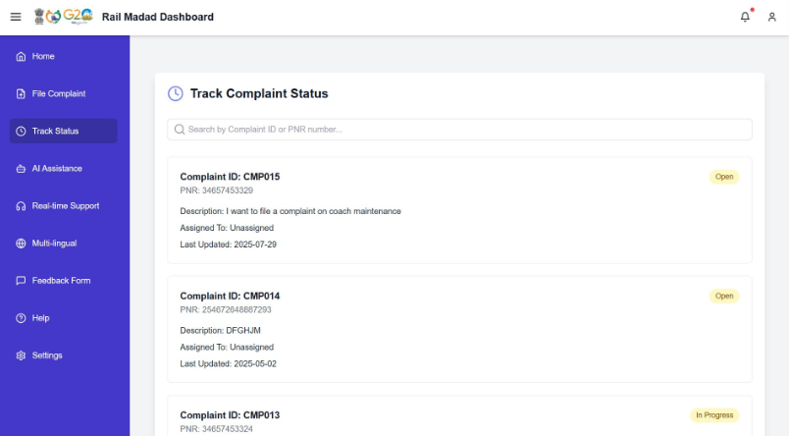

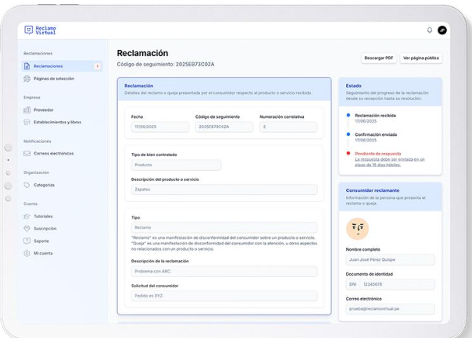

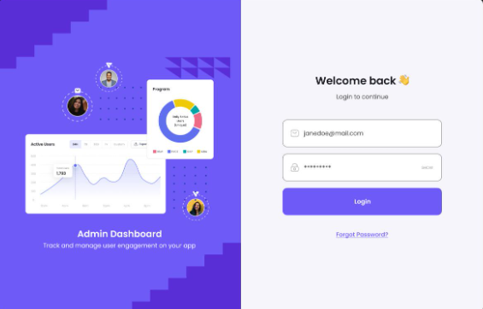

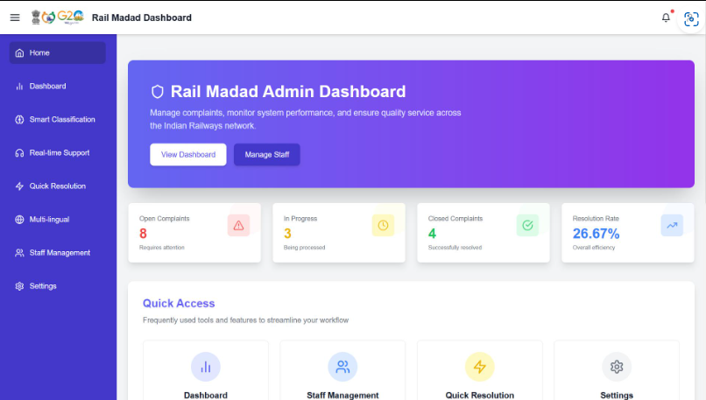

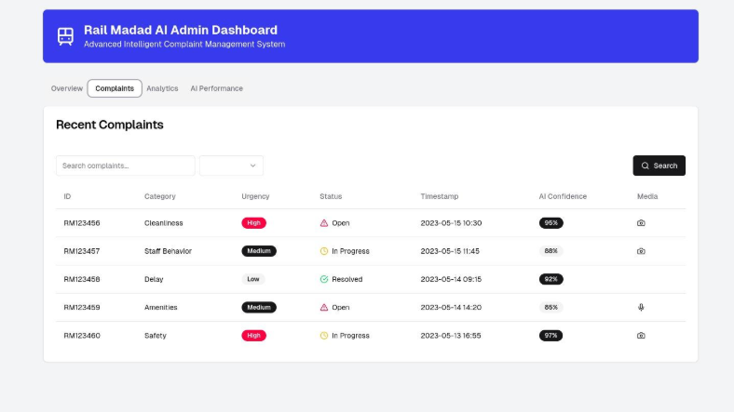

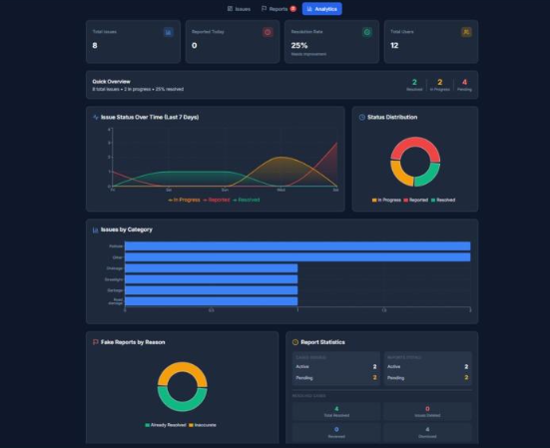

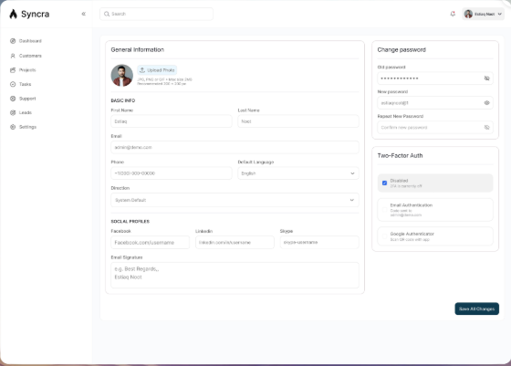
SCREENSHOTS OF WEB PAGES NAME:
1.REGISTRATION PAGE
2. LOGIN PAGE
3.USER DASBOARD
4. REPORT ISSUE PAGE
5.AI ISSUE ANALSIS
6.MY COMPLAINT PAGE
7.TRACK COMPLLAINT PAGE
8.ADMIN LOGIN PAGE
9. ADMIN DASBOARD
10.MANAGE ISSUE PAGE
11.REPORTS AND ANALYTICS PAGE
12.USER PROFILE PAGE

IMPORTANT CODE AND EXPLANATION
- User registration and login.
- Database connection.
- Complaint submission.
- AI-based complaint classification.
- Priority prediction.
- Complaint tracking.
- Admin authentication.
- Admin status update.
- Dashboard statistics.
10.Angular frontend integration.
CODE:
from flask import Flask, request, redirect, url_for, session, render_template_string
import sqlite3
import re
from werkzeug.security import generate_password_hash, check_password_hash
from sklearn.feature_extraction.text import TfidfVectorizer
from sklearn.naive_bayes import MultinomialNB
from sklearn.pipeline import Pipeline

app = Flask(_name_)
app.secret_key = "civiconnect_demo_secret"
DB = "civiconnect.db"

# AI training examples
training_texts = [
"road is damaged and full of potholes",
"street road has many holes",
"water pipe is leaking",
"no water supply in our area",
"garbage is not collected",
"dustbin is overflowing",
"street light is not working",
"no lights on the road at night",
"drainage water is overflowing",
"sewage water on the street"
]

training_labels = [
"Road Damage", "Road Damage",
"Water Leakage", "Water Leakage",
"Garbage", "Garbage",
"Streetlight", "Streetlight",
"Drainage", "Drainage"
]

# Train AI text classification model
ai_model = Pipeline([
("tfidf", TfidfVectorizer()),
("classifier", MultinomialNB())
])

ai_model.fit(training_texts, training_labels)

def connect_db():
return sqlite3.connect(DB)

def setup_database():
con = connect_db()
con.execute("""
CREATE TABLE IF NOT EXISTS users(
id INTEGER PRIMARY KEY AUTOINCREMENT,
name TEXT,
email TEXT UNIQUE,
password TEXT
)
""")
con.execute("""
CREATE TABLE IF NOT EXISTS complaints(
id INTEGER PRIMARY KEY AUTOINCREMENT,
user_email TEXT,
description TEXT,
category TEXT,
priority TEXT,
status TEXT
)
""")
con.commit()
con.close()

def analyze_issue(description):
category = ai_model.predict([description])[0]

urgent_words = [
"emergency", "danger", "accident",
"overflowing", "urgent", "severe"
]

if any(word in description.lower() for word in urgent_words):
priority = "High"
elif category in ["Road Damage", "Drainage", "Water Leakage"]:
priority = "Medium"
else:
priority = "Low"

return category, priority

PAGE = """
<!DOCTYPE html>
<html>
<head>
<title>CiviConnect AI</title>
<style>
body {
font-family: Arial;
background: #eef3f8;
margin: 0;
text-align: center;
}
header {
background: #123b63;
color: white;
padding: 22px;
}
.box {
background: white;
width: 85%;
max-width: 650px;
margin: 25px auto;
padding: 25px;
border-radius: 12px;
box-shadow: 0 2px 10px #bbb;
}
input, textarea {
width: 90%;
padding: 12px;
margin: 9px;
}
button, .btn {
background: #1266a5;
color: white;
border: 0;
padding: 12px 20px;
cursor: pointer;
text-decoration: none;
display: inline-block;
margin: 6px;
}
a { color: #1266a5; }
.item {
background: #f1f5fa;
margin: 12px;
padding: 12px;
text-align: left;
}
</style>
</head>
<body>
<header>
<h1>CiviConnect AI</h1>
<p>Smart Community Issue Reporting System</p>
</header>
<div class="box">
{{ content|safe }}
</div>
</body>
</html>
"""

def page(content):
return render_template_string(PAGE, content=content)

@app.route("/")
def home():
return page("""
<h2>Welcome to CiviConnect AI</h2>
<p>Report community problems and track their progress.</p>
<a class="btn" href="/register">Register</a>
<a class="btn" href="/login">Login</a>
<a class="btn" href="/admin">Admin</a>
""")

@app.route("/register", methods=["GET", "POST"])
def register():
if request.method == "POST":
name = request.form["name"]
email = request.form["email"]
password = generate_password_hash(request.form["password"])

try:
con = connect_db()
con.execute(
"INSERT INTO users(name,email,password) VALUES(?,?,?)",
(name, email, password)
)
con.commit()
con.close()
return redirect(url_for("login"))
except sqlite3.IntegrityError:
return page("<h3>Email already registered.</h3><a href='/register'>Try again</a>")

return page("""
<h2>User Registration</h2>
<form method="POST">
<input name="name" placeholder="Full Name" required>
<input name="email" type="email" placeholder="Email" required>
<input name="password" type="password" placeholder="Password" required>
<button>Register</button>
</form>
<a href="/">Home</a>
""")

@app.route("/login", methods=["GET", "POST"])
def login():
if request.method == "POST":
email = request.form["email"]
password = request.form["password"]

con = connect_db()
user = con.execute(
"SELECT * FROM users WHERE email=?", (email,)
).fetchone()
con.close()

if user and check_password_hash(user[3], password):
session["user"] = email
return redirect(url_for("dashboard"))

return page("<h3>Invalid email or password.</h3><a href='/login'>Try again</a>")

return page("""
<h2>User Login</h2>
<form method="POST">
<input name="email" type="email" placeholder="Email" required>
<input name="password" type="password" placeholder="Password" required>
<button>Login</button>
</form>
<a href="/">Home</a>
""")

@app.route("/dashboard")
def dashboard():
if "user" not in session:
return redirect(url_for("login"))

return page("""
<h2>User Dashboard</h2>
<p>Welcome, """ + session["user"] + """</p>
<a class="btn" href="/report">Report an Issue</a>
<a class="btn" href="/mycomplaints">My Complaints</a>
<a class="btn" href="/logout">Logout</a>
""")

@app.route("/report", methods=["GET", "POST"])
def report():
if "user" not in session:
return redirect(url_for("login"))

if request.method == "POST":
description = request.form["description"].strip()

if not description:
return page("<h3>Please enter an issue description.</h3>")

category, priority = analyze_issue(description)

con = connect_db()
cur = con.execute("""
INSERT INTO complaints
(user_email,description,category,priority,status)
VALUES(?,?,?,?,?)
""", (
session["user"], description,
category, priority, "Pending"
))
complaint_id = cur.lastrowid
con.commit()
con.close()

return page(f"""
<h2>Complaint Submitted!</h2>
<h3>Complaint ID: {complaint_id}</h3>
<p>AI Category: {category}</p>
<p>Priority: {priority}</p>
<p>Status: Pending</p>
<a href="/dashboard">Dashboard</a>
""")

return page("""
<h2>Report Community Issue</h2>
<form method="POST">
<textarea name="description" rows="5"
placeholder="Describe your community problem..." required></textarea>
<br><button>Submit Complaint</button>
</form>
<a href="/dashboard">Back</a>
""")

@app.route("/mycomplaints")
def mycomplaints():
if "user" not in session:
return redirect(url_for("login"))

con = connect_db()
rows = con.execute(
"SELECT * FROM complaints WHERE user_email=?",
(session["user"],)
).fetchall()
con.close()

content = "<h2>My Complaints</h2>"

for row in rows:
content += f"""
<div class='item'>
<b>Complaint ID:</b> {row[0]}<br>
<b>Issue:</b> {row[2]}<br>
<b>Category:</b> {row[3]}<br>
<b>Priority:</b> {row[4]}<br>
<b>Status:</b> {row[5]}
</div>
"""

return page(content + "<a href='/dashboard'>Back</a>")

@app.route("/admin", methods=["GET", "POST"])
def admin():
if request.method == "POST":
if (request.form["username"] == "admin"
and request.form["password"] == "admin123"):
session["admin"] = True
return redirect(url_for("admin_dashboard"))

return page("<h3>Invalid admin login.</h3><a href='/admin'>Try again</a>")

return page("""
<h2>Administrator Login</h2>
<form method="POST">
<input name="username" placeholder="Username" required>
<input name="password" type="password" placeholder="Password" required>
<button>Login</button>
</form>
<a href="/">Home</a>
""")

@app.route("/admin-dashboard")
def admin_dashboard():
if not session.get("admin"):
return redirect(url_for("admin"))

con = connect_db()
rows = con.execute("SELECT * FROM complaints ORDER BY id DESC").fetchall()
con.close()

content = "<h2>Admin Dashboard</h2>"

for row in rows:
content += f"""
<div class='item'>
<b>ID:</b> {row[0]} |
<b>User:</b> {row[1]}<br>
<b>Issue:</b> {row[2]}<br>
<b>Category:</b> {row[3]} |
<b>Priority:</b> {row[4]} |
<b>Status:</b> {row[5]}
<form method='POST' action='/update/{row[0]}'>
<select name='status'>
<option>Pending</option>
<option>In Progress</option>
<option>Resolved</option>
</select>
<button>Update Status</button>
</form>
</div>
"""

return page(content + "<a href='/logout'>Logout</a>")

@app.route("/update/<int:complaint_id>", methods=["POST"])
def update(complaint_id):
if not session.get("admin"):
return redirect(url_for("admin"))

status = request.form["status"]
if status not in ["Pending", "In Progress", "Resolved"]:
return "Invalid status", 400

con = connect_db()
con.execute(
"UPDATE complaints SET status=? WHERE id=?",
(status, complaint_id)
)
con.commit()
con.close()

return redirect(url_for("admin_dashboard"))

@app.route("/logout")
def logout():
session.clear()
return redirect(url_for("home"))

if _name_ == "_main_":
setup_database()
print("CiviConnect AI server starting...")
app.run(debug=True)
SAMPLE OUTPUT:
User Registration

Full Name: Abi
Email: abi@gmail.com
Password: ****

[Register]
Complaint Status Updated Successfully

Complaint ID: 1
Category: Road Damage
Priority: Medium
Status: Resolved

SCREENSHOT OF CODE:
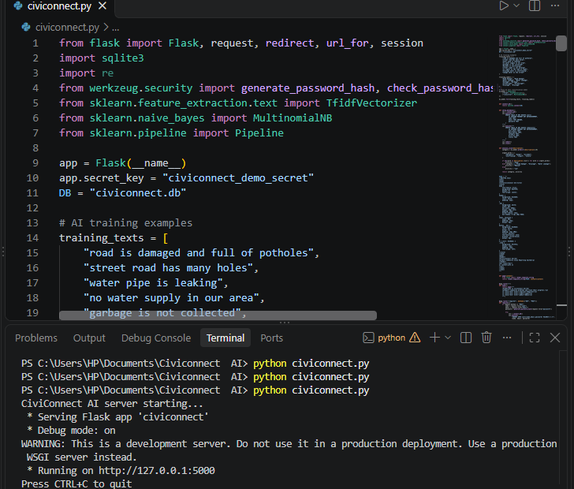
SCREENSHOT OF OUTPUT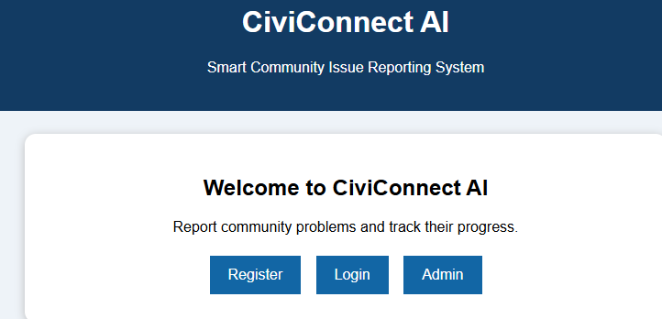
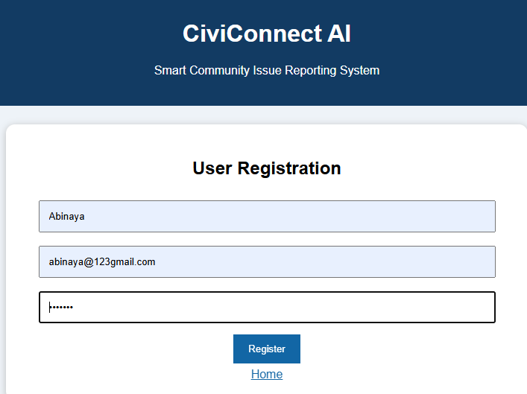

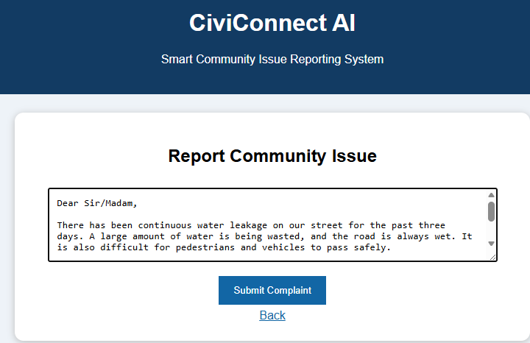
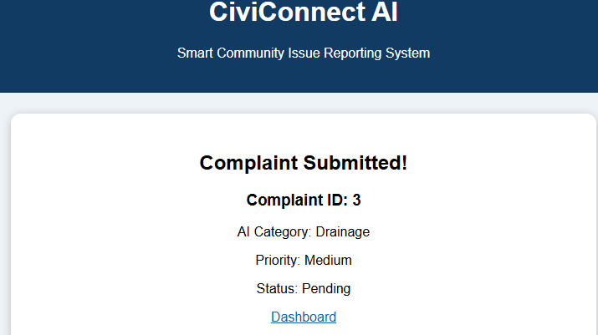

EXPLANATION OF CODE:

CiviConnect AI is a web-based community issue reporting system developed using Python, Flask, SQLite, and Machine Learning. It allows users to register, log in, and report common community problems such as road damage, water leakage, garbage collection, streetlight failures, and drainage issues. The system uses TF-IDF for text feature extraction and the Multinomial Naive Bayes algorithm to automatically classify complaints into different categories. It also assigns priority levels based on predefined conditions.
The application stores complaint details in an SQLite database. Users can view and track their submitted complaints through the dashboard. Administrators can access all complaints, review the reported issues, and update their status as Pending, In Progress, or Resolved. The main objective of CiviConnect AI is to simplify community problem reporting, improve complaint management, and support faster communication between citizens and administrators.
Hosting Requirements
Python programming language.
Flask web framework.
SQLite database.
Required Python libraries.
GitHub repository containing the project code.
Render hosting platform.
Hosting Process
Create a GitHub account.
Upload the CiviConnect AI project files to GitHub.
Create an account on Render.
Connect the GitHub repository to Render.
Configure the Python environment and start command.
Deploy the application.
Access the application using the generated public URL.
Expected Hosting Output
After successful deployment, CiviConnect AI will be accessible through a public website URL. Users can access the application without running the Python program on their local computers.
CHALLENGES FACED
During the development of the CiviConnect AI project, several challenges were encountered. Integrating the Flask framework with the SQLite database, handling user registration and login, and managing complaint details required careful implementation. Another challenge was developing the AI model to classify different community complaints using TF-IDF and the Naive Bayes algorithm. Assigning appropriate priority levels and updating complaint statuses also required proper testing and debugging. These challenges helped improve programming knowledge, problem-solving skills, and understanding of machine learning and web application development.
CONCLUSION
CiviConnect AI is a smart community issue reporting system developed to simplify the process of reporting and managing public problems. The application allows users to submit complaints, automatically classify issues using machine learning, and track their complaint status. It also provides an administrator dashboard to manage complaints and update their progress. This project demonstrates the practical application of Python, Flask, SQLite, and Artificial Intelligence in solving real-world community problems. Overall, CiviConnect AI aims to improve communication between citizens and administrators and support efficient community management.

